You should be prepared for the fact that taking care of your teeth will be more difficult once you get braces. Braces have countless tiny spaces to trap food, and this trapped food causes plaque, which can lead to many other dental problems. Because of this, it's very important to brush your teeth after every meal (snacks count, too), to rinse with mouthwash, and to floss at least once a day. This may seem tedious or excessive, but neglecting your oral hygiene can lead to serious oral health problems, force you to spend additional time in braces, or cause unsightly staining on your teeth. The extra responsibility needed to care for braces properly is something that both you and your child should be prepared for.
TOOTHBRUSHING:
Ideally you should brush at least 3 times a day (morning,noon and night). We recommend using a soft bristled toothbrush and replacing it every 3 months. It is ideal to brush after a meal, but if you can’t brush it is helpful to rinse your mouth out with water to remove any loose food particles. It is also very important to keep up with your regular dental cleanings and check ups. A cleaning is recommended every 6 months unless otherwise specified by your dentist. The use of electric toothbrushes and/or water piks during orthodontics treatment is fine. Use on low speed to avoid lossening or breaking your applieances and/or fillings. Swollen, red, bleeding gums is an indication that the patient is not cleaning his/her teeth and gums properly. If this should occur, you must conitnue to brush your teeth and massage your gums even if they hurt and/or bleed in order to regain your healthy smile. Tooth brushing, while in your orthodontic appliances, takes time and should not be rushed.
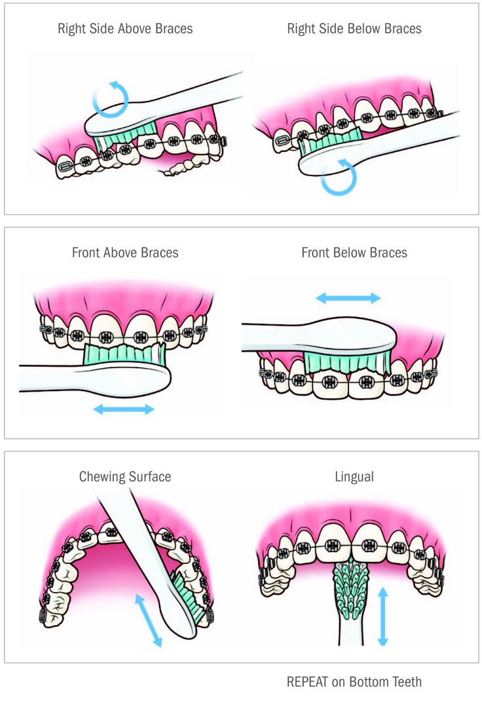
FLUORIDE MOUTHRINSE:
We recommend using a rinse as an added protection to help in the fight against cavities and staining pf the teeth. Permanenet stains on your teeth around the braces occur only when you do not remove food, plaque, and bateria thoroughly from oue teeth and gums. Use rinse before bedtime and after thoroughly brushing your teeth, rinse with one teaspoon for one minute and spitout. DO NOT SWALLOW RINSE
ORABASE OINTMENT:
We recommend the use of this ointment for canker sores, cuts, and irritations. Please be aware that canker sores can be uncomfortable and take as long as 2 weeks to heal.
ORTHODONTIC WAX:
Wax is to be used if your braces are rubbing or poking the inside of your mouth and may be necessary until the inside of your mouth toughens up and you be become accustomed to your braces. Wax usage is an individual choice and may or may not be used throughout the entire course of treatment. You only need a small amount of the wax placed on the brace or wire that is irritating you to act as a buffer so the skin will not be as tender. If you should happen to swallow some wax, do not worry it is not harmful. DO NOT chew the wax. Chewing the wax will cause the appliances to lossen or break. We recommend keeping wax with you at all times.
IF SOMETHING BREAKS/LOOSE:
If anythings gets loose or breaks please contact the office immediately for an appointment. Loose or broken braces or wire are not an emergency and may not need immediate attention unless you are in pain

FOOD TO AVOID:
At the end of this information package there is list of somespecific itams to avoid. Foods that are sticky and chewy tend to pull and tug on the mental in your mouth. This may cause the it to lossen. Hard and/or crunchy food can lossen a brace or wire imeediately. Loose or broken braces may slow up the treatment. FOODS TO AVOID DURING ORTHODONTIC TREATMENT
Do not eat sticky and/or chewy food such as:
- Gum of any kind
- Anything that may contain Caramels(ex. Baby Ruth, snickers etc)
- Jelly beans
- Licorice
- Milk duds
- Now & laters
- Tootsie Rolls
- Bagels
- Taffy
10. Soft Pretzels
Do not eat hard and/or crunchy food such as:
- Chips (Fritos, Doritos, Pretzels, etc)
- Cookies
- Hard candy (lifesavers, lollipops ,jaw breakers, etc)
- nerds
- Ice Cubes
- Any type of Brittle
- Pizza Crust
- Hard bread thick buns or bagels
- Hard fruits (apples, pears, peaches) unless they are sliced or cooked.
- Hard vegetables (carrots, celery, broccoli etc) unless they are shaved, grated or cooked
- Popsicles ( if hard like ice)
- Hard shell tacos
- Ice cream cones
- Nuts of any kind
- Corn on the cob
- Meat on the bone
- Chewable vitamins and candy
- Keep fingers and objects out your mouth
- DO NOT PLAY WITH BRACKETS

